**Prompt Bibliothek**

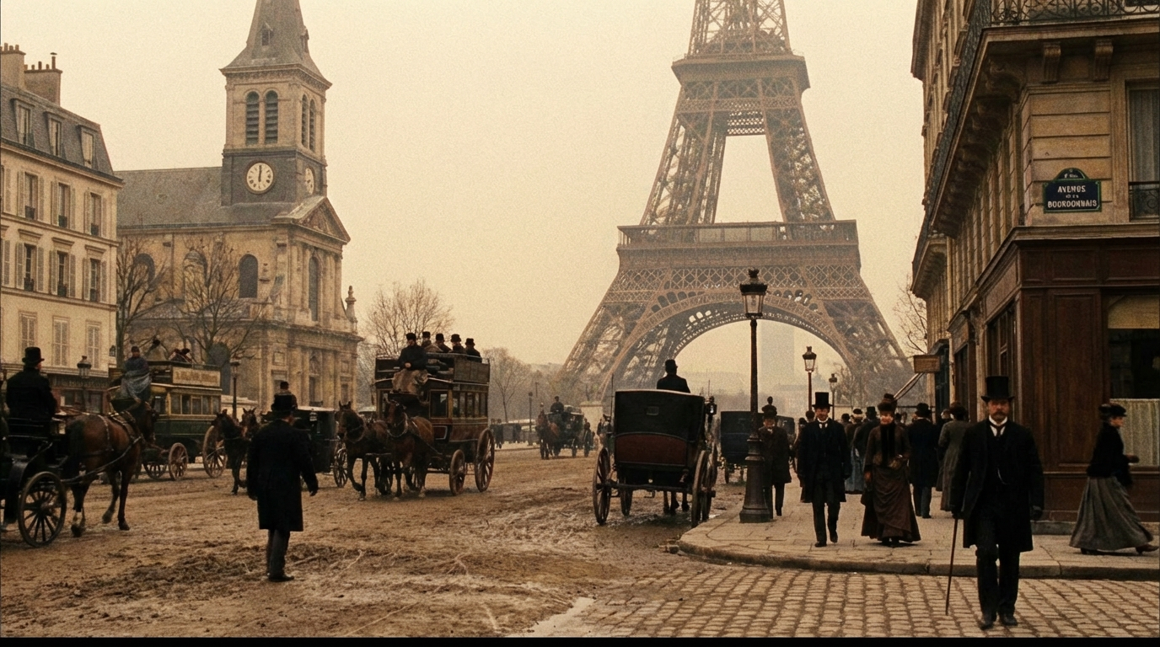

**Prompt:**

Recreate a historically accurate cinematic scene based on this data. Location 48.8584° north, 2.2945° east, Paris, France. Date, the 15th of June, 1888. Time 3:00 p.m

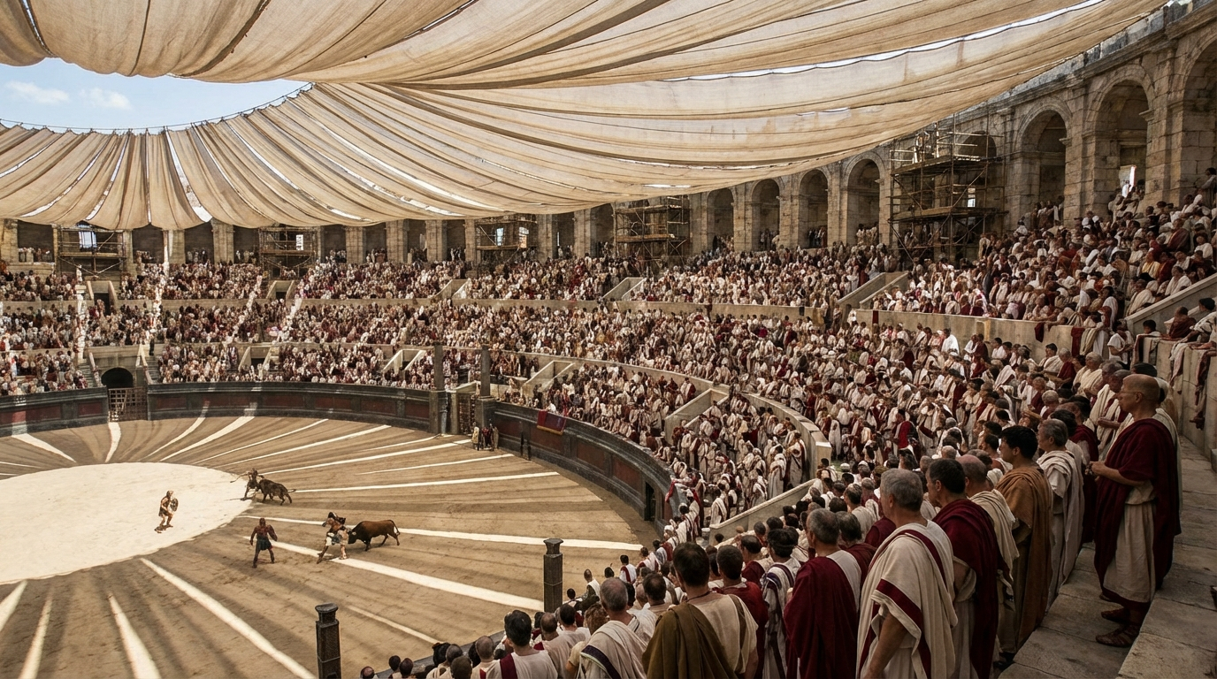

**Prompt:**

Recreate a historically accurate scene. Location: The Colosseum, Rome. Date: 80 AD. Time: 2:00 PM. Show the inaugural games, the crowd density, the velarium awning providing shade, and the sandy arena floor.

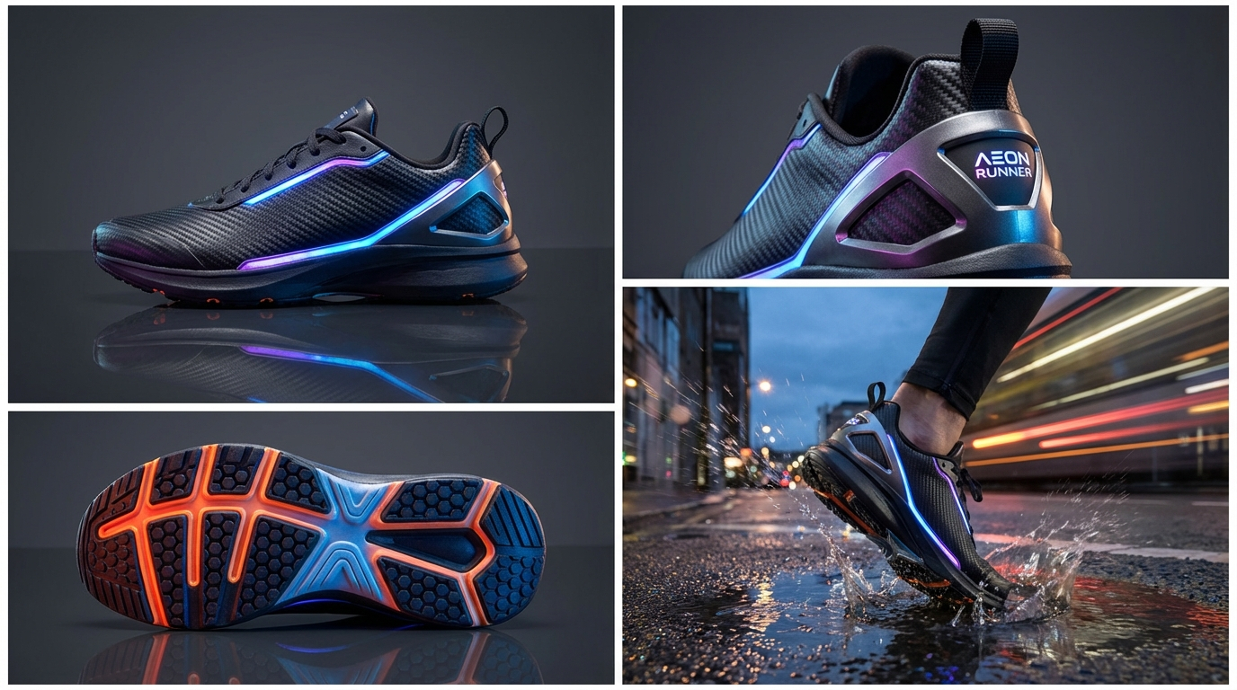

**Prompt:**

Generate multi-angled product shots for a futuristic running sneaker. Include a sole tread close-up, a heel detail shot, and a dynamic action shot of the shoe splashing through a puddle

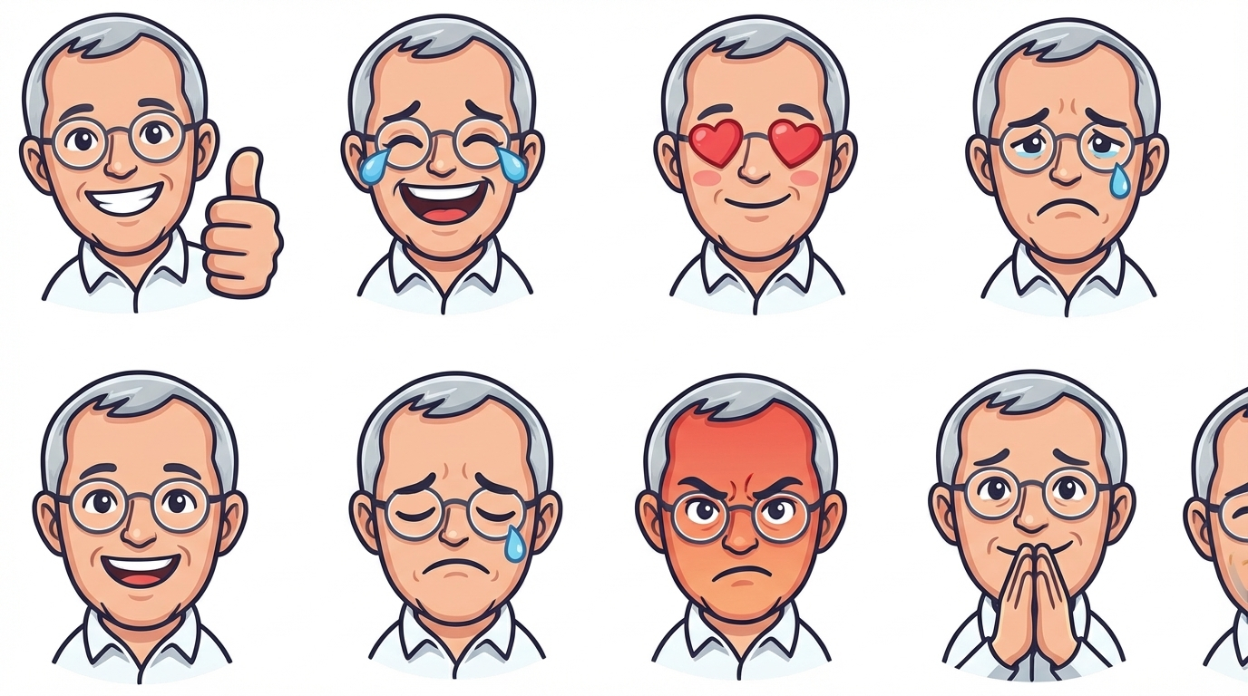

**Prompt:**

Create a complete emoji reaction pack for the attached character

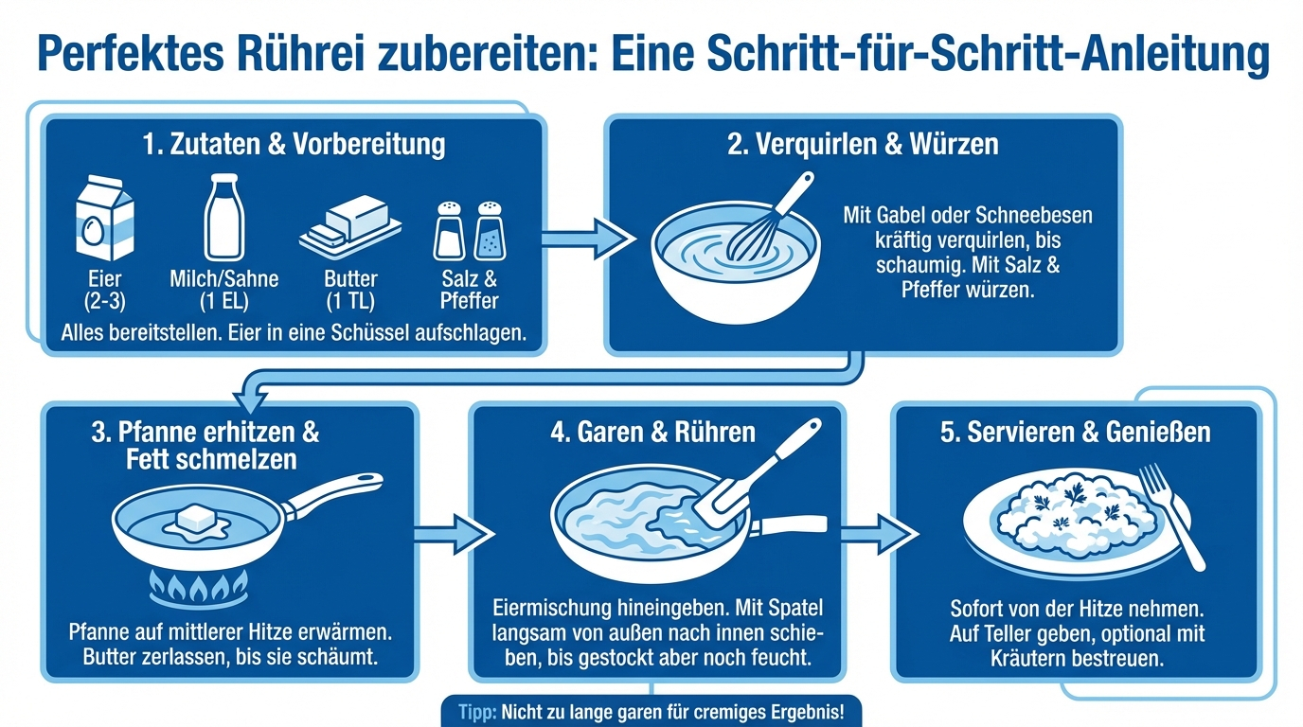

**Prompt:**

Erstelle eine detaillierte Infographik, wie man ein Rührei zubereitet. Alle Texte in Deutsch, die Farben blau und weiß verwenden

|  |  |
| --- | --- |
| Unveiling Strength in Monochrome Elegance | **Hinweise:**  Im Prompt werden für den Gesichtsausdruck Referenzbilder verwendet, die man für Nano Banana Pro mit hochladen kann. |

**Prompt:**

|  |
| --- |
| {  "Title": "High-Contrast Monochrome Assertiveness Portrait",  "Objective": "To capture a dramatic, high-contrast, black and white portrait emphasizing a dominant, mysterious, and effortlessly cool demeanor with a pensive pose.",  "SubjectDetails": {  "Gender": "Female",  "Appearance": {  "Hair": "Sleek, neat bun or pulled-back hairstyle",  "Expression": "Neutral yet intense, mysterious, direct gaze through sunglasses, or pensive look.",  "Pose": "Hand resting gently on the chin/jawline, looking slightly to the side. Posture is confident and stable.",  "FacialFeatures": "The subject should maintain the same facial structure and features as the reference image (1000045331.jpg and 1000054961.jpg) for consistency."  },  "Wardrobe": {  "Top": "Simple, solid black crewneck or high-neck casual sweater/top",  "Accessories": [  "Large, dark black square or wayfarer **sunglasses**",  "Minimal or no jewelry"  ]  }  },  "LightingAndTone": {  "LightingStyle": "Dramatic **High-Contrast Split Lighting** or Rembrandt lighting, with a single, strong light source.",  "Tone": "**Bold, dark, and monochromatic** (Black and White)",  "Highlights": "Sharp highlights on the nose bridge, cheekbones, and the hand/fingers near the face.",  "Shadows": "**Pure, deep black shadows** to blend seamlessly with the background and create a stark outline"  },  "BackgroundAndSetting": {  "Environment": "Pure studio environment",  "Focus": "Subject in sharp focus (shallow depth of field)",  "Texture": "Smooth, textureless, and **infinite black background** (Vantablack effect)"  },  "CameraSettings": {  "LensType": "85mm or 105mm prime lens (portrait lens)",  "Aperture": "f/4 – f/5.6 for maximum sharpness across the face and outfit",  "Style": "Gritty and cinematic **Monochrome**",  "PostProcessing": [  "Aggressive increase in **clarity and contrast**",  "Set black point to absolute zero for deep shadows",  "Sharpen facial features and any visible hand details"  ]  },  "MoodAndDirection": {  "Theme": "Understated Power, Dominance, and Mystery",  "Emotion": "Composed, controlled, and thoughtful/pensive."  }  } |

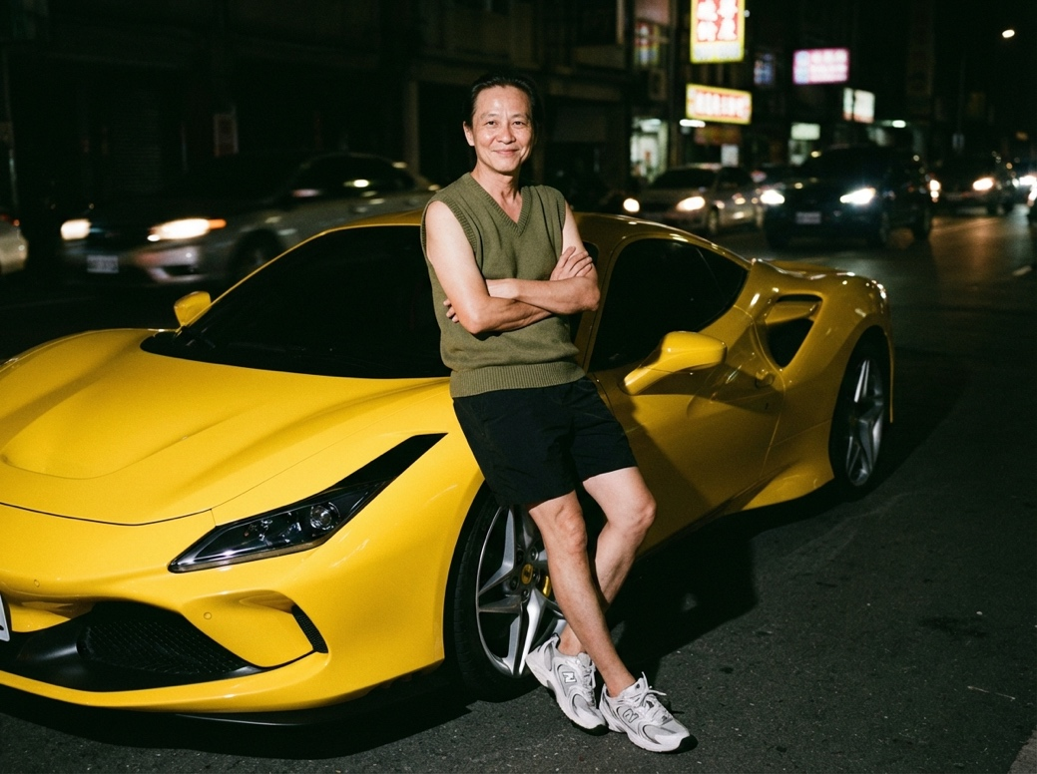

**Prompt:**

|  |
| --- |
| {  "image_metadata": {  "resolution": "1200x1200px",  "genre": "Candid street portrait",  "editing_note": "Face edited without alteration to features"  },  "photography_style": {  "medium": "Analog 35mm film-style",  "overall_aesthetic": [  "raw",  "nostalgic",  "gritty"  ],  "visual_artifacts": {  "grain": "Subtle but distinct film grain visible throughout frame",  "bokeh": "Soft in background"  },  "color_grade": {  "palette": "Muted and slightly warm",  "contrast": "High contrast (typical of flash)"  }  },  "lighting_characteristics": {  "primary_source": {  "type": "Camera flash",  "direction": "Direct, shining on face and body"  },  "effects_on_subject": {  "highlights": "Strong",  "shadows": "Sharp, cast behind subject",  "skin_glow": "Slight glow from flash"  },  "ambient_light": {  "level": "Minimal",  "sources": [  "streetlights",  "car headlights",  "neon signs"  ],  "appearance": "Blurred and slightly halated"  }  },  "subject_details": {  "pose": {  "stance": "Leaning on the front left of the Ferrari F8",  "arms": "Folded across chest",  "style": "Natural, candid"  },  "expression": "Slight smile towards the camera",  "features": {  "age": "Middle-aged",  "skin_texture": "Natural with subtle age lines"  },  "attire": {  "top": "Army green V-neck knit vest",  "bottom": "Black shorts",  "footwear": "White-grey New Balance 530 sneakers"  }  },  "environmental_context": {  "time_of_day": "Night",  "setting": "Dark city street",  "key_elements": {  "foreground_object": "Bright yellow Ferrari F8",  "background": {  "brightness": "Dark",  "noise_level": "Minimal"  }  }  }  } |

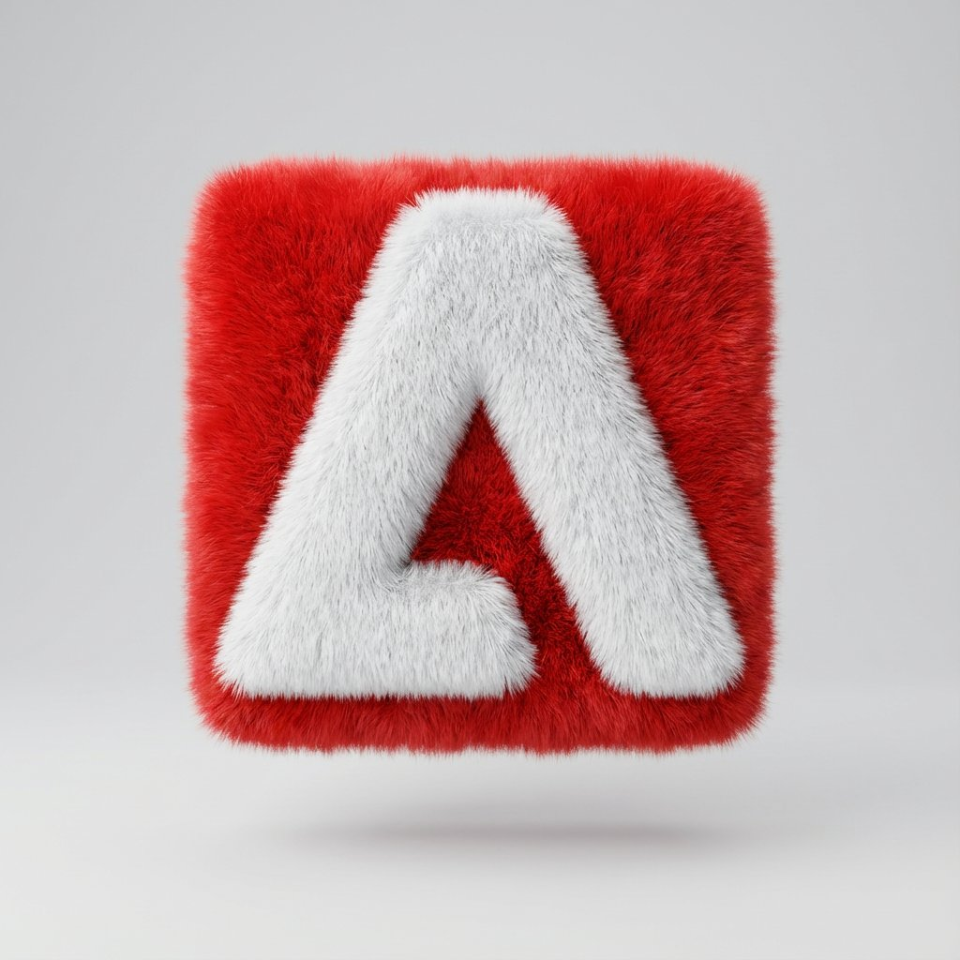

|  |
| --- |
| {  "image_metadata": {  "resolution": "1200x1200px",  "genre": "Candid street portrait",  "editing_note": "Face edited without alteration to features"  },  "photography_style": {  "medium": "Analog 35mm film-style",  "overall_aesthetic": [  "raw",  "nostalgic",  "gritty"  ],  "visual_artifacts": {  "grain": "Subtle but distinct film grain visible throughout frame",  "bokeh": "Soft in background"  },  "color_grade": {  "palette": "Muted and slightly warm",  "contrast": "High contrast (typical of flash)"  }  },  "lighting_characteristics": {  "primary_source": {  "type": "Camera flash",  "direction": "Direct, shining on face and body"  },  "effects_on_subject": {  "highlights": "Strong",  "shadows": "Sharp, cast behind subject",  "skin_glow": "Slight glow from flash"  },  "ambient_light": {  "level": "Minimal",  "sources": [  "streetlights",  "car headlights",  "neon signs"  ],  "appearance": "Blurred and slightly halated"  }  },  "subject_details": {  "pose": {  "stance": "Leaning on the front left of the Ferrari F8",  "arms": "Folded across chest",  "style": "Natural, candid"  },  "expression": "Slight smile towards the camera",  "features": {  "age": "Middle-aged",  "skin_texture": "Natural with subtle age lines"  },  "attire": {  "top": "Army green V-neck knit vest",  "bottom": "Black shorts",  "footwear": "White-grey New Balance 530 sneakers"  }  },  "environmental_context": {  "time_of_day": "Night",  "setting": "Dark city street",  "key_elements": {  "foreground_object": "Bright yellow Ferrari F8",  "background": {  "brightness": "Dark",  "noise_level": "Minimal"  }  }  }  } |

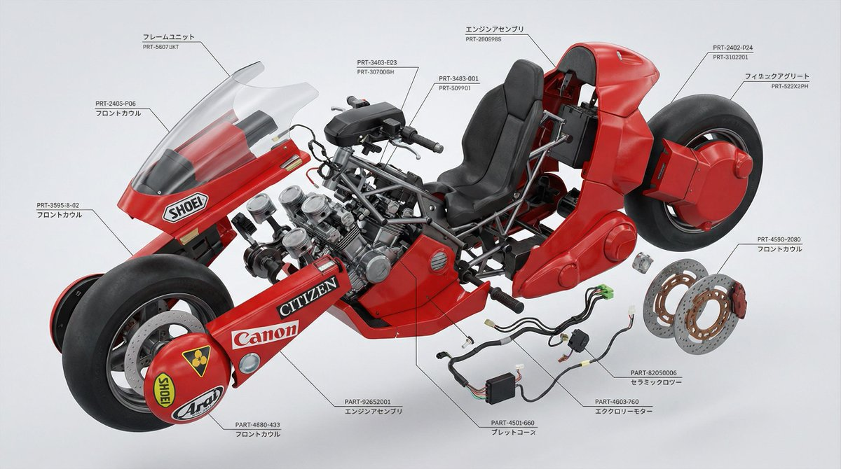

|  |
| --- |
| Generate an ultra-detailed, hyperrealistic exploded technical view of Kaneda’s iconic red motorcycle from Akira. The image should show every component separated in 3D space, floating in a clean engineering layout, with perfect alignment and labeled layers. Keep the perspective dynamic but readable, like a premium industrial design schematic. |

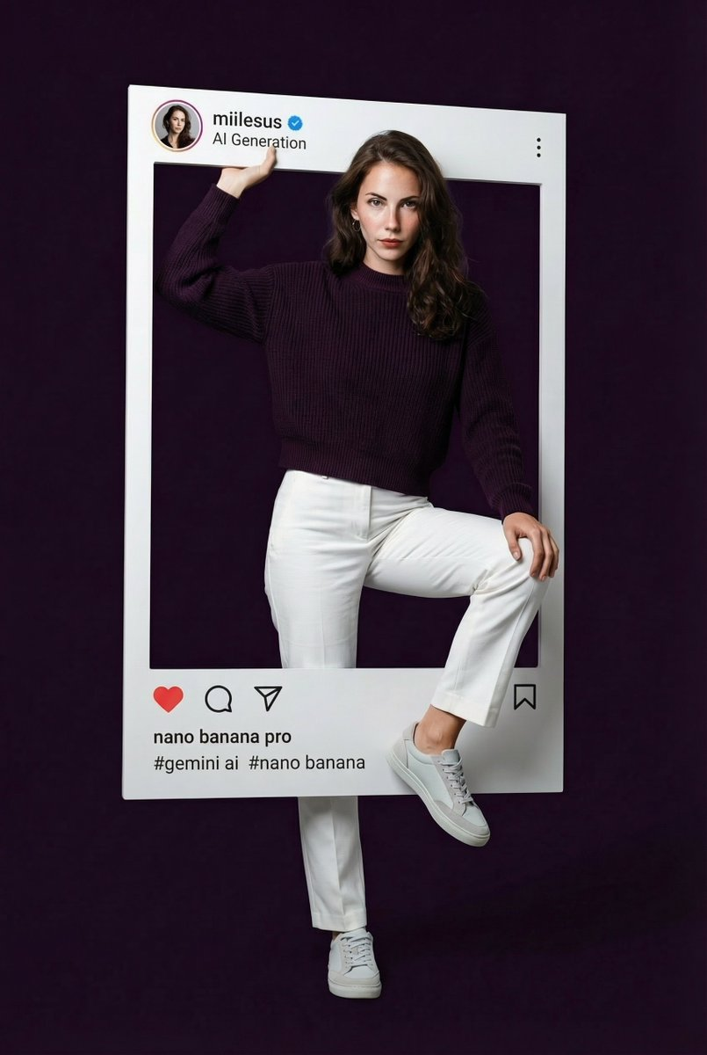

|  |
| --- |
| Create a hyper-realistic portrait of the beautiful woman from the reference photo, presented inside an oversized Instagram post frame that dominates the scene. Her facial features remain identical to the reference delicate yet sharp, clean, and naturally stunning.  She stands in a modern, slightly dynamic pose: upper body leaning subtly forward as if engaging directly with the viewer, one hand casually gripping the top edge of the Instagram frame, while one leg steps gracefully outward through the frame, creating a smooth and stylish 3D illusion. The pose feels youthful, fresh, effortlessly elegant, and confidently cool.  Give her a high-fashion model expression—eyes locked onto the viewer with calm, magnetic intensity; lips relaxed and neutral; jawline softly defined. No smile or smirk—just a strong, clean, modern editorial gaze with subtle freshness and quiet power.  She wears a ribbed knit sweater in hex color #18091D, high-waisted straight-fit white trousers, and sleek white-grey low-top sneakers, creating a crisp, cool-toned outfit with rich contrast.  The Instagram frame is ultra-realistic with:  username “miilesus”  verified badge  display name “AI Generation”  caption “nano banana pro”  hashtags under the caption: “#gemini #nanobanana #ai”  authentic Instagram UI icons (like, comment, share, save)  a circular profile picture identical to the reference photo of her  Background:  Use a solid background in the deep tone #18091D, with no gradients clean, smooth, modern, and slightly cinematic.  Lighting should be clean and high-end, accentuating the structure of her face, the ribbed texture of the knit sweater, and the 3D breakout effect. The final result should feel modern, bold, and editorial. |

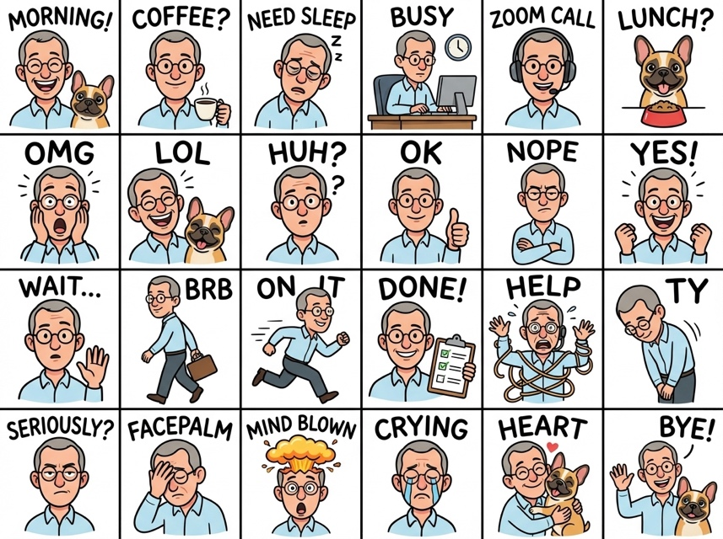

Upload Image:

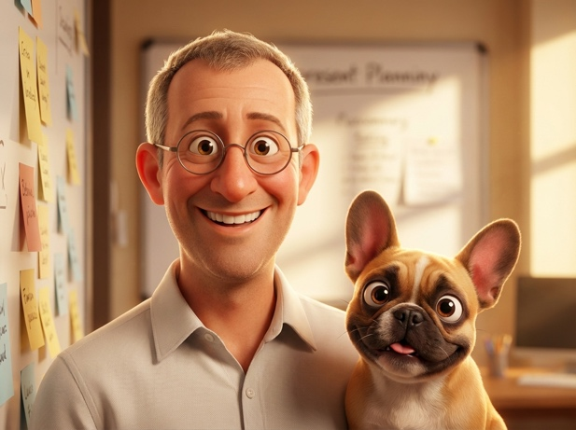

|  |
| --- |
| Create a set of colorful, hand-drawn LINE-style half-body Q-version emoji portraits using the image attached for the portrait, ensuring accurate depiction of their head accessories.  Arrange the images in a 4x6 layout, featuring common chat phrases or relevant humorous memes.  Use handwritten-style fonts for text.  Output must reference the portrait of the person in the attached image.  Final image should be in 4K resolution, 16:9 aspect ratio. |

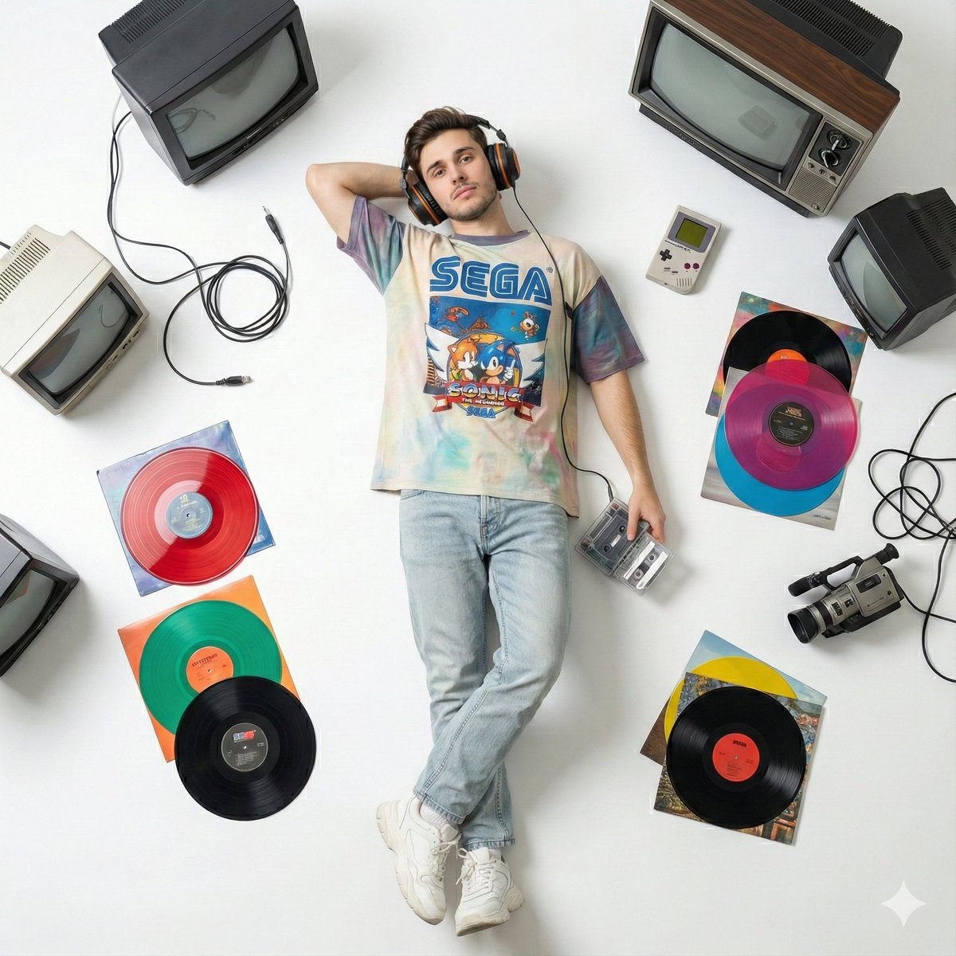

|  |
| --- |
| A top-down perspective of a young man lying on a clean white floor, styled in a classic 90s outfit: a loose graphic tee, light-washed denim jeans, chunky sneakers, and over-ear retro headphones. He holds a portable cassette player in one hand, the tape slightly exposed. Scattered around him are colorful vinyl records, chunky old CRT televisions, and vintage electronics, arranged with clear spacing to create a nostalgic 90s atmosphere. |

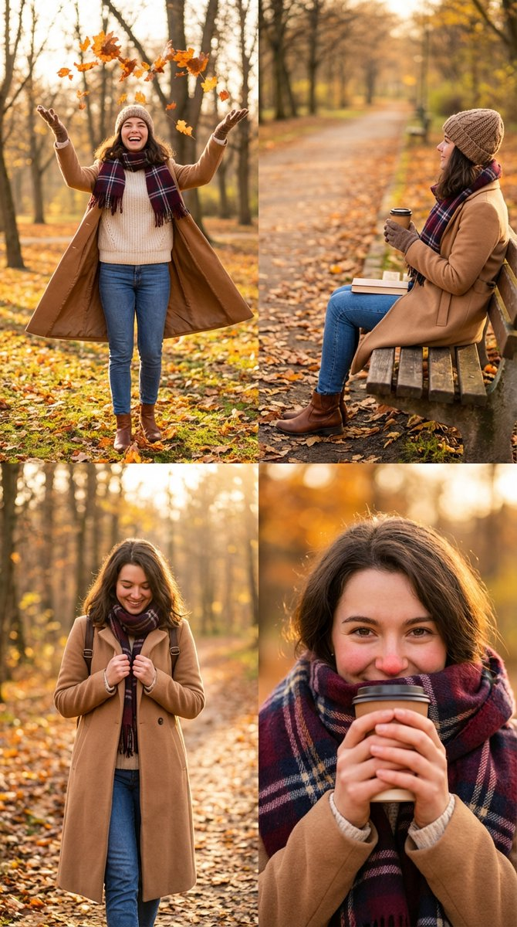

|  |
| --- |
| {  "scene_description": "A cohesive 4-panel fashion lifestyle collage featuring the same young woman in a cozy layered autumn outfit, showcasing relaxed poses in nature.",  "subject": {  "type": "Young Woman (Consistent character)",  "age": "early 20s",  "features": {  "hair": "loose natural hair with beanie",  "makeup": "rosy cheeks"  },  "attire": "chunky knit sweater, plaid scarf, long wool coat, jeans, boots",  "accessories": "takeaway coffee cup"  },  "collage_layout": {  "structure": "2x2 Grid Layout (4 frames of equal size)",  "panel_1_top_left": "Full Body Dynamic: Throwing autumn leaves in the air or twirling, coat flowing, smiling broadly.",  "panel_2_top_right": "Sitting Side View: Sitting on a park bench with legs crossed, reading a book or looking at the scenery, holding coffee.",  "panel_3_bottom_left": "Mid-Shot Walking: Walking towards the camera holding the lapels of the coat, looking down shyly or smiling.",  "panel_4_bottom_right": "Portrait with Prop: Peeking out from behind the oversized scarf, holding the coffee cup near face for warmth, eyes smiling."  },  "environment": {  "setting": "Autumn Park / Forest Path",  "background_elements": [  "Orange and yellow leaves",  "Trees",  "Park bench"  ]  },  "lighting": {  "style": "Golden Hour Soft",  "key_light": {  "type": "Low Autumn Sun",  "color": "Warm Golden",  "effect": "Backlight or soft front light, magical atmosphere"  }  },  "style": {  "medium": "Portrait Photography",  "aesthetic": "Cottagecore, Autumn Vibes, Cozy, Pinterest",  "quality": "8k resolution, warm tones"  },  "attire_customization": {  "current_clothing": "Wool coat and knitwear",  "customizable_clothing": "User can swap for puffer jacket or raincoat"  },  "brand_product_customization": {  "current_brand_product": "Winter Apparel",  "customizable_brand": "User: Insert Brand Name",  "customizable_product": "User: Specific coat or boots",  "product_placement_area": "Coat texture or boots"  }  } |

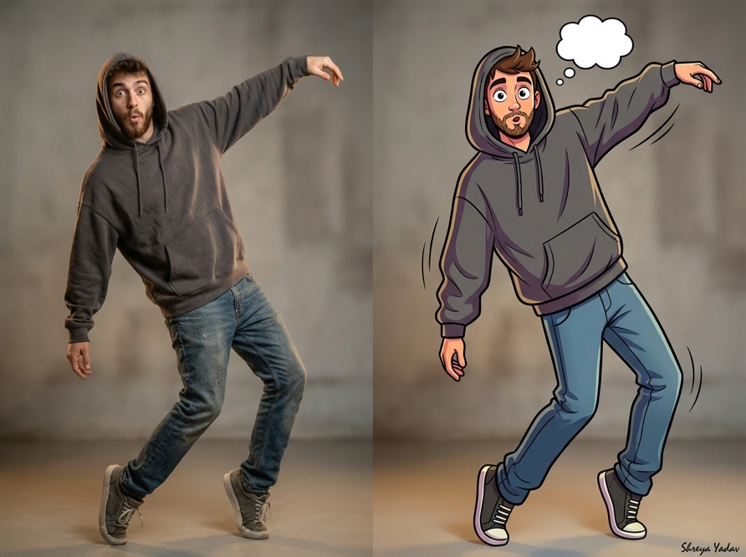

|  |
| --- |
| {  "prompt": "A realistic photograph of a man wearing a trendy hoodie, striking an exaggerated, animated pose. Next to him is his exact lookalike, rendered in a lively American cartoon style (think 90s/early 2000s animation) with the same haircut, same facial features, and same exaggerated stance. The cartoon figure should be highly stylized, colorful, and dynamically rendered. The background is soft, minimal, and neutral to emphasize both figures. Cinematic lighting, high detail. Signature: Shreya Yadav.",  "image_count": 1,  "art_style": [  "photorealistic",  "american cartoon style"  ],  "composition": [  "side-by-side comparison",  "full-body shot",  "minimal background"  ],  "details": [  "trendy hoodie",  "exaggerated animated pose",  "high detail",  "cinematic lighting"  ],  "signature": "Shreya Yadav"  } |

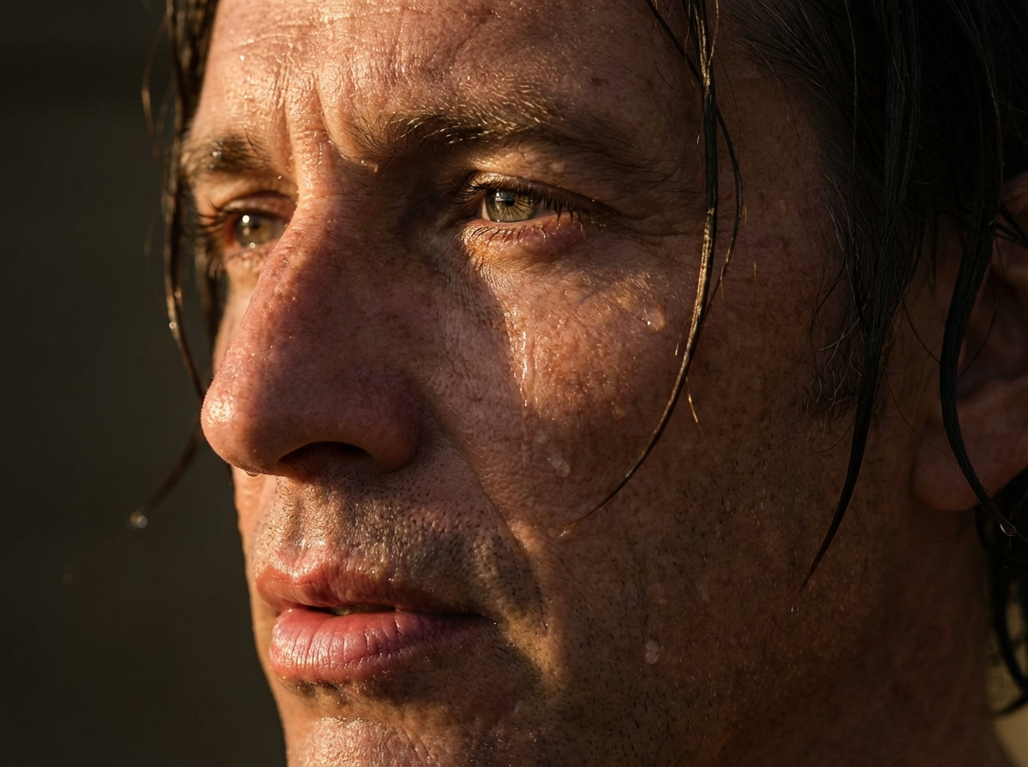

|  |
| --- |
| {  "prompt_title": "Hyper-realistic Close-up Portrait (Wet Skin, Golden Hour)",  "style_and_quality": {  "rendering_style": "Hyper-realistic close-up",  "resolution": "8K",  "focus": "Extremely shallow depth of field (DoF)",  "aesthetic_effect": "Ultra-detailed cinematic effect, soft realistic contrast, golden tones and deep shadows"  },  "photography_equipment": {  "camera": "Hasselblad H6D-400c",  "lens": "100mm f/2.2 lens"  },  "composition_and_framing": {  "framing": "Close-up",  "subject_placement": "Captures only the left side of the face",  "key_focus_point": "Eye in absolute focus with a crisp catchlight"  },  "subject_details": {  "model_gender": "Man",  "age": "50-60 years old",  "facial_features_to_maintain": "Faithfully maintaining all facial features from reference photo, thick, well-defined eyebrow, long wet lashes",  "skin_texture_emphasis": "Microtextural details, pores, freckles, natural texture of wet skin",  "lips": "Full, slightly parted, and wet lips; texture highlighted by directional lighting"  },  "water_and_texture": {  "skin_covering": "Skin covered in water droplets running down naturally",  "highlights": "Vivid specular highlights due to light angle, moist reflections on the lips and nose"  },  "lighting_setup": {  "type": "Simulated warm late afternoon light (Golden Hour)",  "main_source": "Large side softbox",  "fill_and_bounce": "Combined with a gold reflector",  "effect": "Soft yet intense glow on the water on the man's face, precisely highlights micro-details"  },  "hair_details": {  "placement": "Wet strands of hair fall along the right side of the face",  "interaction": "Clinging to the skin without altering any facial features"  }  } |

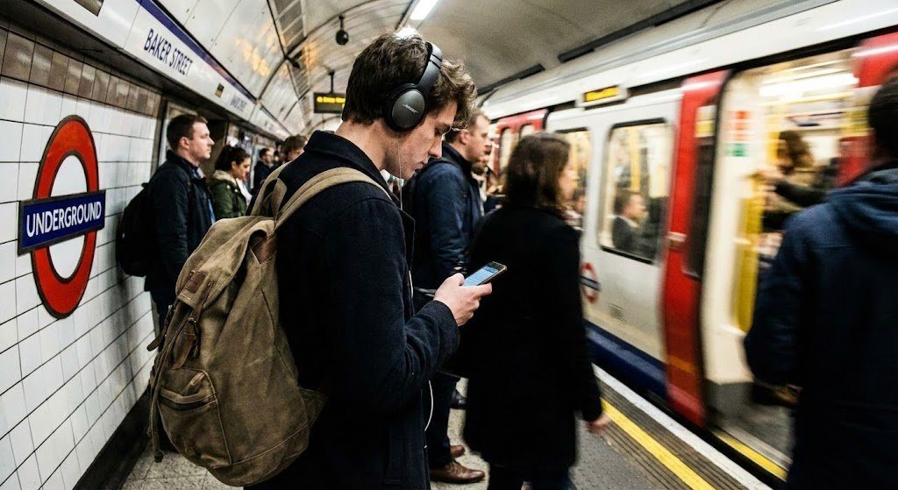

|  |
| --- |
| London Underground Station  A digital snapshot captures a student with a backpack and headphones waiting on a crowded subway platform. The blurred image shows a train pulling in and other commuters. |

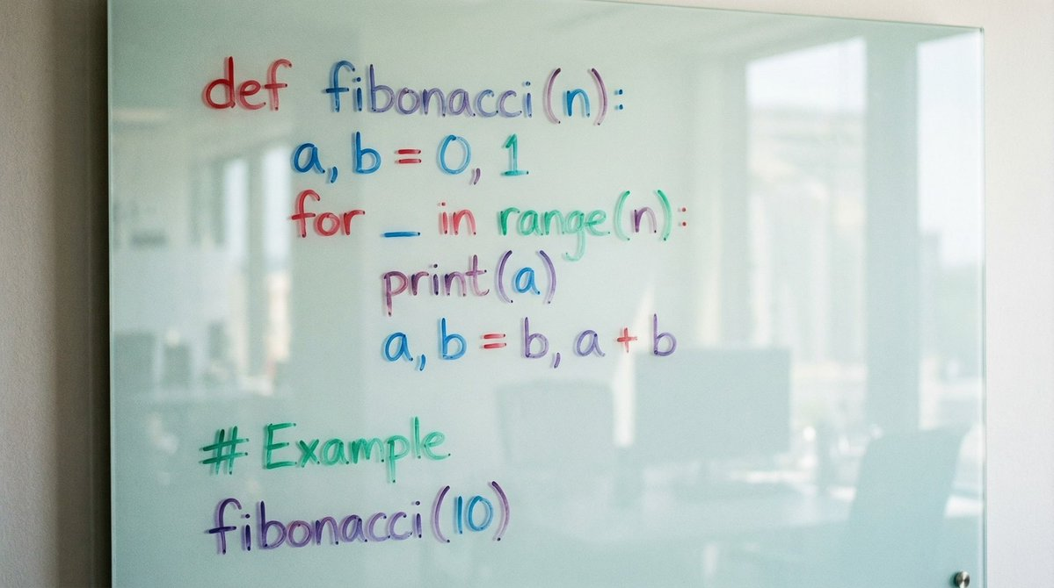

|  |
| --- |
| create a photo of python code to calculate the fibonacci numbers drawn on a glass whiteboard with coloring markers |

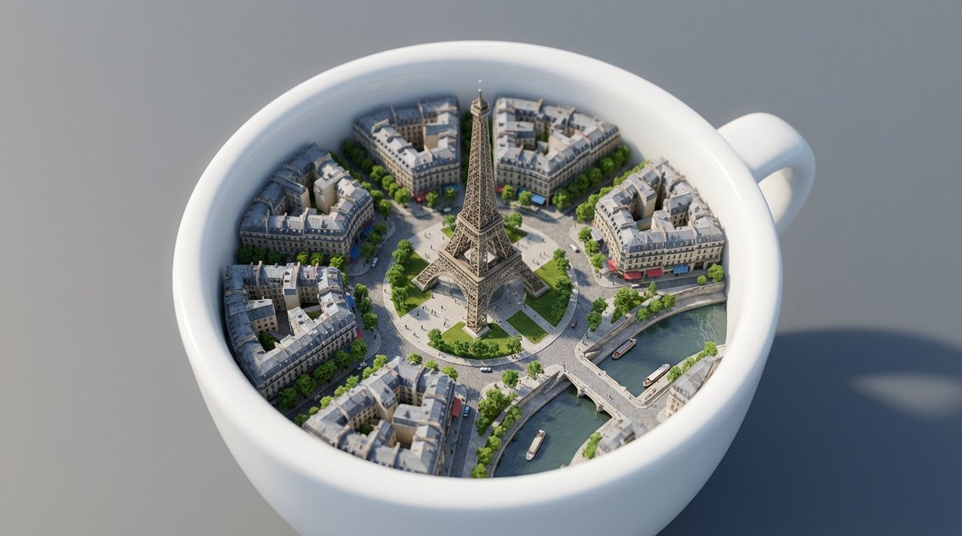

|  |
| --- |
| White ceramic coffee cup rests on a smooth gray surface, its interior transformed into a miniature version of Paris. Instead of liquid, the cup contains tiny detailed streets, Haussmann-style buildings with gray rooftops, tree-lined boulevards, and small cafés with awnings. At the center rises a perfectly scaled Eiffel Tower, made of intricate metallic latticework, towering over a circular plaza and grassy park with tiny walking figures. Bridges span across a tiny river resembling the Seine that curves through the cup, with miniature boats floating beneath. The perspective is top-down, with gentle depth-of-field blur at the cup’s edges, focusing sharply on the Eiffel Tower as the focal point. Soft daylight casts realistic shadows, and the city textures—cobblestone streets, glass windows, and greenery—appear ultra-detailed, giving the illusion of a living Paris contained within a cup. |

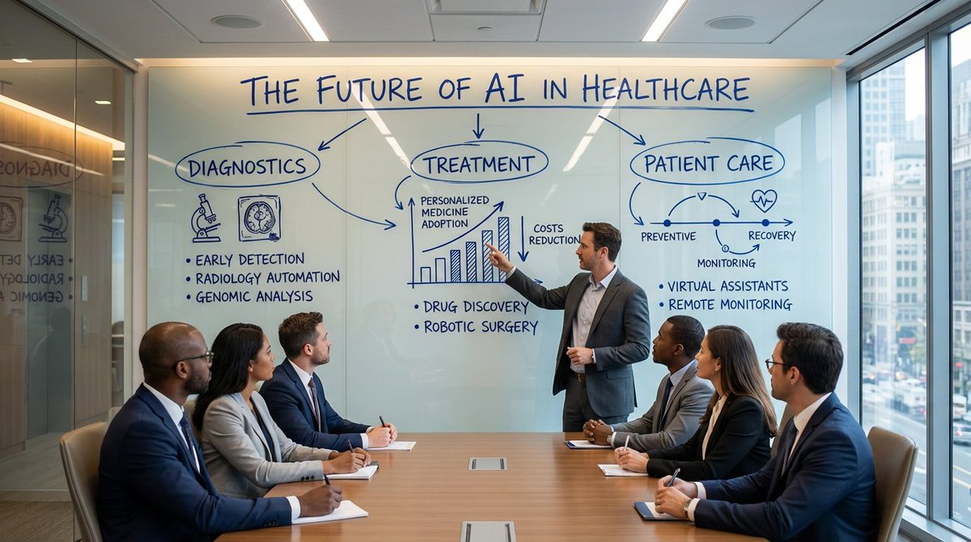

|  |
| --- |
| Ultra-realistic scene in a modern corporate conference room, 16:9. A large wall-mounted glass board is the focal point, covered in deep cobalt-blue marker in natural human handwriting. A presenter stands beside the board, mid-gesture, explaining the content to a group of professionals seated around a sleek conference table, all facing the board and paying close attention.  Text and diagrams are clearly handwritten: bold all-caps headings, slightly imperfect; italic subheadings; smaller, neat notes; arrows and icons with slight wobble and pressure variation. The blue ink looks convincingly real with darker edges, subtle streaks, glossy reflections, and tiny smudges at stroke ends.  Topic on the board: THE FUTURE OF AI IN HEALTHCARE, divided into three hand-drawn clusters (DIAGNOSTICS, TREATMENT, PATIENT CARE) with sketched icons, a rough bar chart, and a circular mini-timeline. Glass shows reflections of room lights and attendees, background with windows and city hints, cinematic, premium office lighting, 8K |

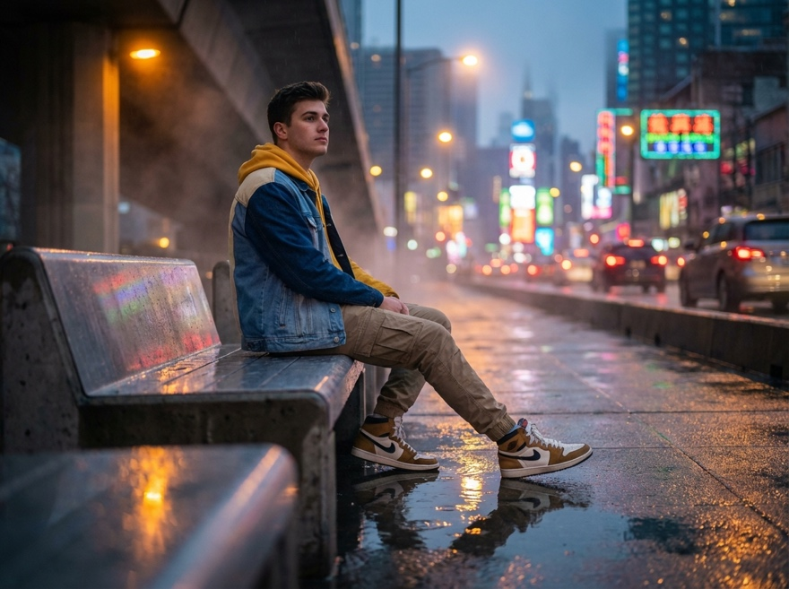

Generiert mit dem unstehenden Prompt

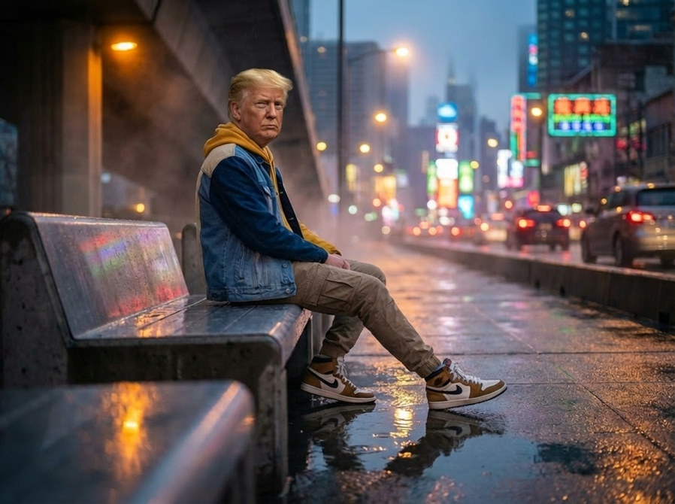

Upload erstes Foto plus Portrait von Donald Trump und dann folgender Prompt:

|  |
| --- |
| swap the face of the person on the bench with the person portrait of the other image |

|  |
| --- |
| {  "objective": "Generate a cinematic, photo-realistic image of the person in the uploaded image",  "scene_description": {  "setting": {  "location": "Rain-soaked flyover bench at dusk",  "environment_details": [  "wet pavement with puddle reflections",  "mist in the air",  "vibrant neon cityscape in the background",  "bokeh trails from passing cars"  ]  },  "subject": {  "type": "person in the uploaded image",  "pose": "sitting on the bench, low-angle perspective",  "appearance": {  "outfit": {  "jacket": "colorblock denim jacket",  "inner_wear": "yellow hoodie",  "pants": "khaki cargo pants",  "footwear": "high-top sneakers"  }  }  }  },  "camera_and_style": {  "camera_angle": "cinematic low-angle shot",  "focus": {  "subject_focus": "sharp 8K clarity on subject",  "foreground": "intentionally blurred"  },  "color_grading": "moody mix of warm streetlights and cool neon tones",  "lighting": [  "ambient neon glow",  "warm streetlights",  "reflections in puddles"  ],  "aesthetics": [  "cinematic depth",  "high contrast",  "atmospheric realism"  ]  },  "output_preferences": {  "resolution": "8K highly detailed",  "style": "cinematic realism"  }  } |

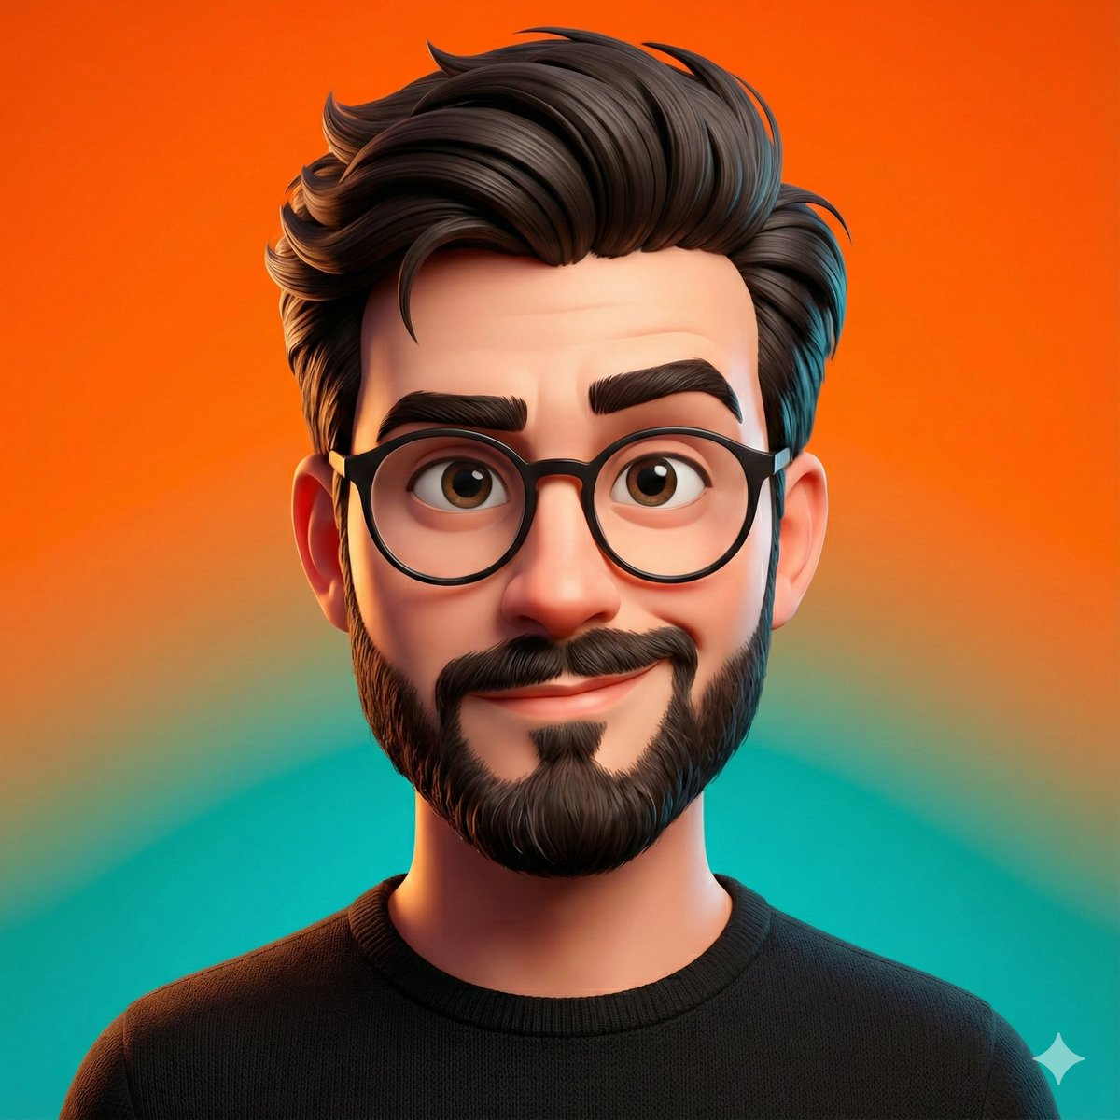

|  |
| --- |
| A highly stylized 3D caricature of the person in the uploaded image, with expressive facial features, and playful exaggeration. Rendered in a smooth, polished style with clean materials and soft ambient lighting. Bold color background to emphasize the character’s charm and presence. |

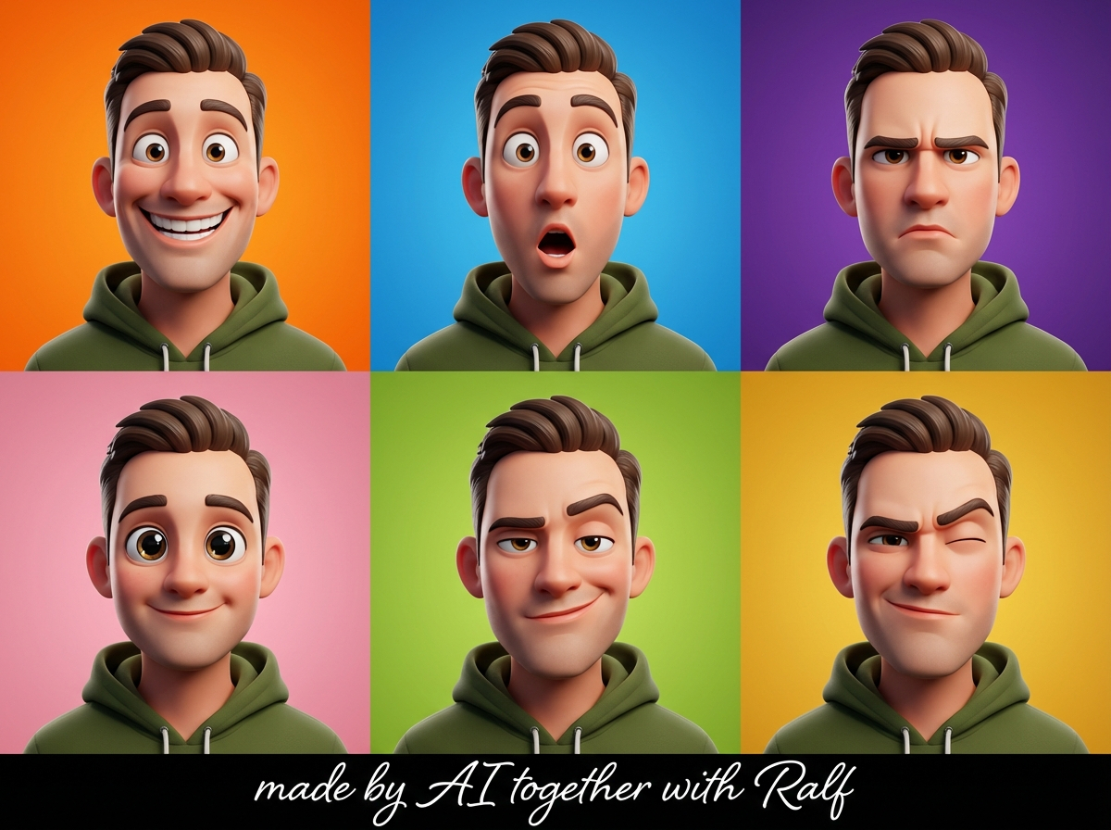

|  |
| --- |
| {  "project_name": "3D_Caricature_Collage_Olive_Green",  "prompt_structure": {  "subject": {  "type": "Man",  "style": "3D Caricature",  "appearance": "Highly polished, clean, meticulous detail",  "clothing": "Deep olive green hoodie (rich, muted earth tone)"  },  "composition": {  "type": "Collage",  "layout": "Six-panel grid (3 columns x 2 rows)",  "framing": "Upper-body close-up portraits"  },  "variations": {  "panel_1": "Happy",  "panel_2": "Surprised",  "panel_3": "Serious",  "panel_4": "Cute",  "panel_5": "Sassy",  "panel_6": "Confident",  "facial_features": "Artistic exaggerations, widened eyes, arched eyebrows, broad smiles"  },  "environment": {  "background": "Bold, vibrant colors distinct for each panel",  "lighting": "Soft ambient lighting, sculpting subtle textures, crisp definition"  },  "text_elements": {  "content": "made by AI together with Ralf",  "type": "Signature",  "style": "Elegant, legible"  }  },  "technical_params": {  "aspect_ratio": "3:4",  "quality": "High definition, 8k, cinematic lighting",  "render_engine": "Octane render / Unreal Engine style"  },  "full_prompt_text": "A six-panel collage (3 columns, 2 rows) featuring a highly polished 3D caricature of a man wearing a deep olive green hoodie. The character maintains a consistent identity across all panels but displays six distinct emotions: happy, surprised, serious, cute, sassy, and confident. Each panel shows an upper-body close-up. Facial features are artistically exaggerated with widened eyes and expressive mouths. Soft ambient lighting highlights skin texture and fabric folds. Backgrounds are bold and vibrant, contrasting with the muted olive hoodie. High-end digital art style, crisp definition. Signature text 'made by AI together with Ralf' included."  } |

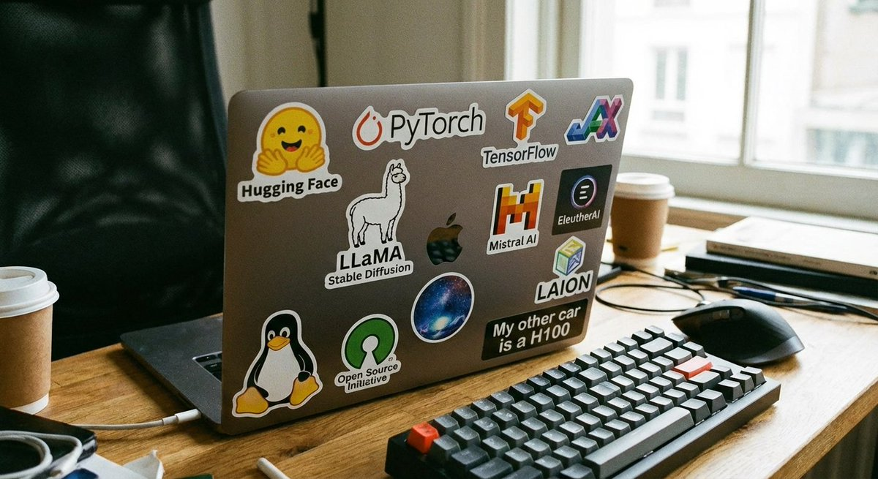

|  |
| --- |
| generate a laptop with stickers. the laptop belongs to a fan of open source ML models |

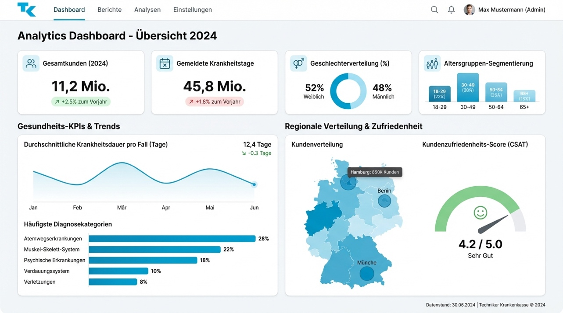

|  |
| --- |
| Create a sleek analytics dashboard website UI for the German health insurance provider Techniker Krankenkasse (TK). The dashboard should display key customer statistics including:  total number of customers in 2024,  total number of sick-leave days reported by customers,  gender distribution (% female vs. male),  customer age-group segmentation,  and additional relevant healthcare-focused KPIs such as: average sick-leave duration per case, most common diagnostic categories, regional customer distribution, and customer satisfaction score.  Use a clean, modern design with a professional theme reflecting TK’s branding (light theme with TK-blue accents or a refined dark theme with healthcare-appropriate blues and greens). I want it in the form of an image: the complete UI/UX of the dashboard page that I can share directly with my developer for implementation. Do not provide a mockup frame—deliver the actual full dashboard page UI design as an image. Do not provide code; only the creative dashboard image that fits these requirements. |

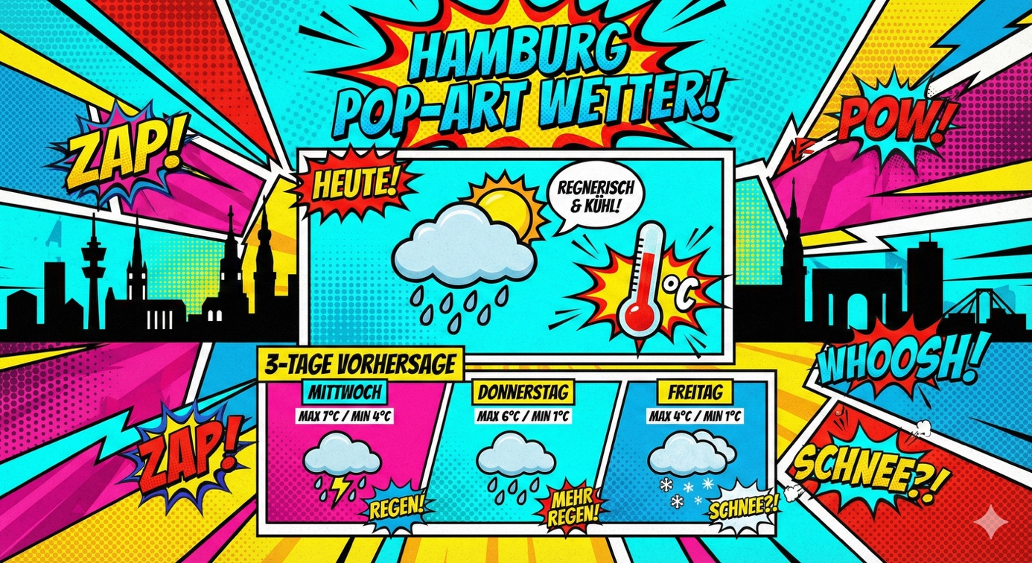

|  |
| --- |
| Create a vibrant pop-art style infographic showing today’s weather in Hamburg with temperature, conditions, and a 3-day forecast. Write the text in german language |

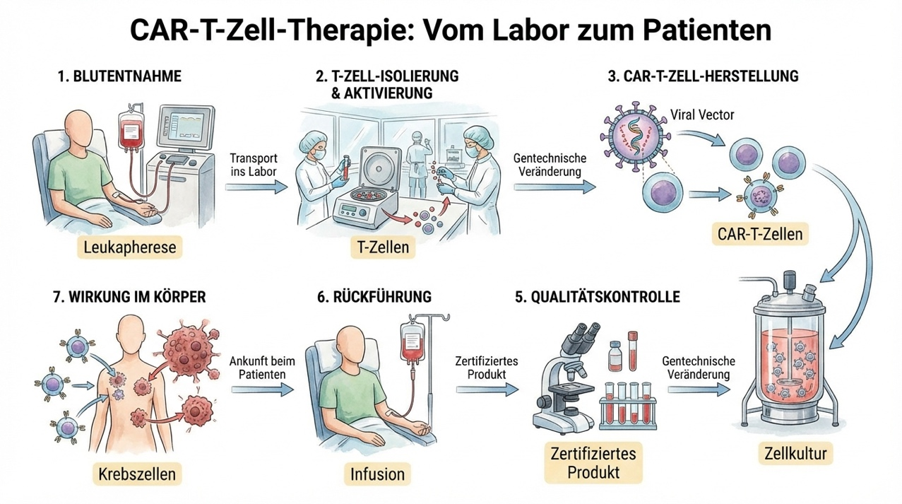

|  |
| --- |
| In an illustration describe all of the stages of CAR-T cell therapy from lab to patients. All texts are in german language |

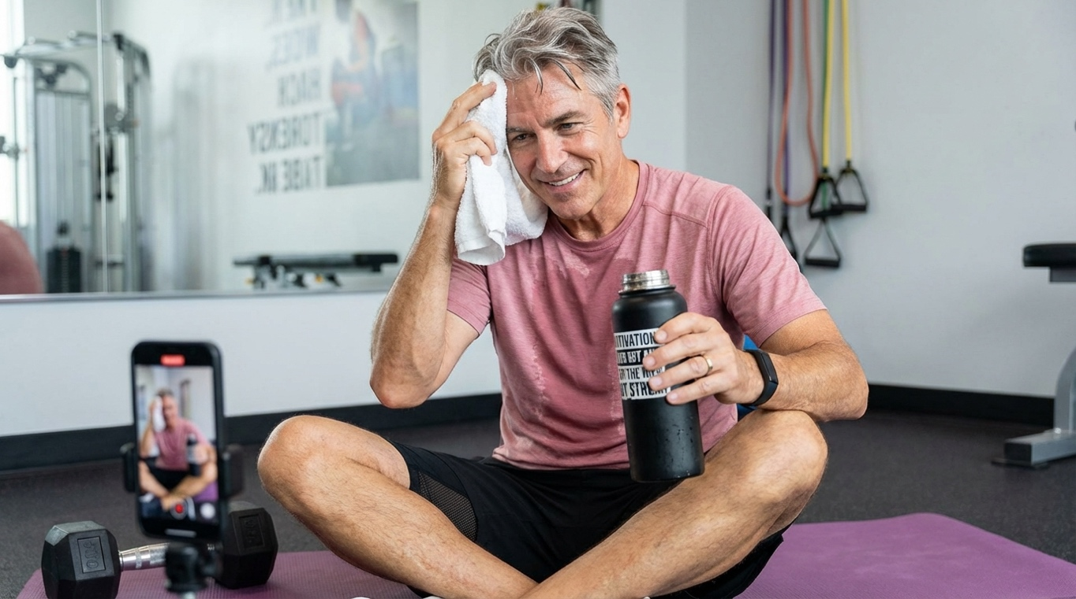

|  |
| --- |
| {  "subject": {  "description": "A man in his early 60s sitting on a yoga mat, wiping sweat with a towel, holding a water bottle",  "mirror_rules": "N/A - direct gym photo",  "age": "early 60s",  "expression": "accomplished, slight breathlessness, warm confident smile",  "hair": {  "color": "gray with some darker streaks",  "style": "short, slightly tousled from workout"  },  "clothing": {  "top": {  "type": "moisture-wicking athletic t-shirt",  "color": "dusty rose pink (same color palette as original)",  "details": "lightweight performance fabric, sweat visible around chest and collar"  },  "bottom": {  "type": "athletic training shorts",  "color": "black with subtle mesh panels",  "details": "knee length, breathable mesh side sections, relaxed fit"  }  },  "face": {  "preserve_original": true,  "makeup": "none, natural flushed complexion from workout"  }  },  "accessories": {  "headwear": {  "type": "none",  "details": "no head covering"  },  "jewelry": {  "earrings": "none",  "necklace": "none",  "wrist": "sleek black fitness tracker",  "rings": "simple wedding band (optional)"  },  "device": {  "type": "smartphone",  "details": "propped against dumbbell, recording workout selfie"  },  "prop": {  "type": "insulated water bottle",  "details": "matte black 32oz bottle with motivational quote sticker, condensation visible"  }  },  "photography": {  "camera_style": "gym selfie aesthetic, smartphone front camera",  "angle": "slightly above eye level, sitting position",  "shot_type": "full upper body and crossed legs, centered composition",  "aspect_ratio": "9:16 vertical",  "texture": "crisp detail, bright gym lighting, energetic feel"  },  "background": {  "setting": "modern gym studio",  "wall_color": "light gray with motivational mural",  "elements": [  "purple yoga mat laid out",  "set of dumbbells scattered nearby",  "white towel draped over shoulder",  "blurred gym equipment in background",  "large mirror reflecting back wall",  "resistance bands coiled on floor"  ],  "atmosphere": "energetic, accomplished, health-focused",  "lighting": "bright overhead LED gym lighting, even coverage"  }  } |

**Serie von Prompts mit einem Ausgangsbild (Portrait Shooting)**

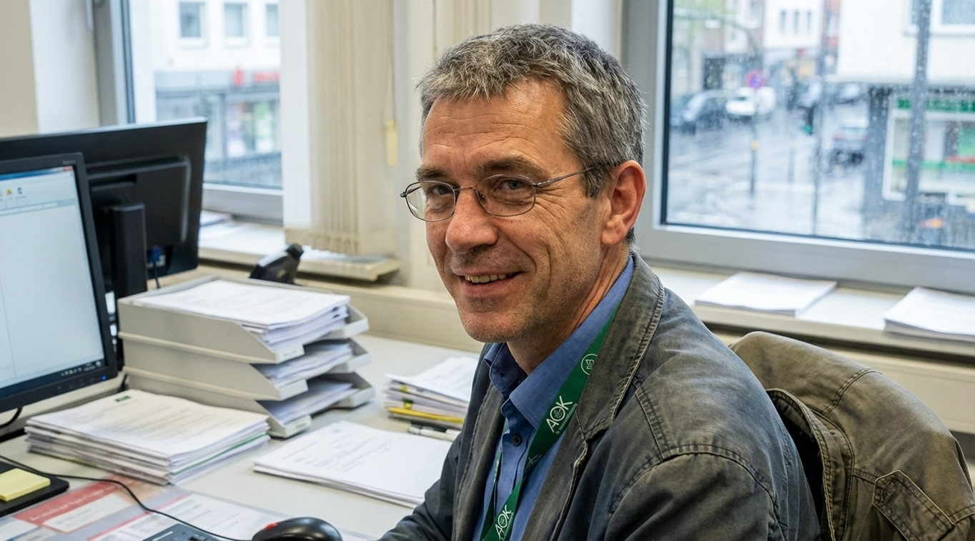

**Prompt für das obige Portrait:**

|  |
| --- |
| portrait shot of a 45 year old man working for a public health insurance in german |

Mit dem obigen Portrait Foto kann man jetzt mit Nano Banana Pro von Google weiterarbeiten

**Prompts:**

|  |
| --- |
| Create an image of me working at a modern workspace, adjusting a design on a tablet using Adobe Photoshop. |

**Beschreibe die Szene:**

Beschreibe stattdessen eine Szene so, wie du sie einem menschlichen Fotografen schildern würdest.

Szenen helfen dem Modell, Folgendes zu verstehen:

* die Umgebung
* die Stimmung
* die beabsichtigte Handlung
* die Atmosphäre

**Werde konkret: Komposition, Stil, Seitenverhältnis, Details**  
Nano Banana Pro ist nicht nur leistungsstark — es ist gehorsam. Es folgt detaillierten Anweisungen hervorragend.

Wenn du klare, präzise Ergebnisse möchtest, gib Folgendes an:

* Beleuchtung
* Ort
* Bildausschnitt
* Outfit
* Stimmung
* Seitenverhältnis

Zum Beispiel:

|  |
| --- |
| Generate an image of me cleaning a stain off a shirt in a clean corporate tutorial style. Use a 16:9 aspect ratio. |

**Nutze Fusion- & Multimodal-Funktionen wie ein Profi**

Eine der am meisten unterschätzten Stärken von Nano Banana Pro ist seine Fähigkeit, mehrere Bilder zu kombinieren und die Charakteridentität über verschiedene Szenen hinweg beizubehalten.

Wenn du das brauchst, dann fordere es an.

Zum Beispiel mit diesem Foto und dem Portrait oben:

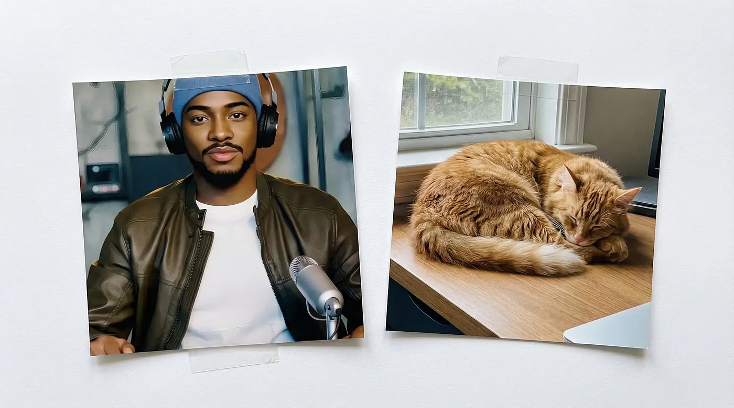

|  |
| --- |
| Blend these two photos — me and my cat in a garden — and keep the lighting consistent using Nano Banana’s fusion ability. |

**Sprich wie ein Mensch — nicht wie ein Technikhandbuch**  
Dieses Modell braucht keine steifen, technischen Prompts. Natürliche Sprache funktioniert am besten.

Beispiele

|  |
| --- |
| Please switch my outfit to a vintage style, keeping my face and proportions intact |

|  |
| --- |
| Hi Gemini, I’ve got this selfie — please use Nano Banana Pro to switch my outfit to a retro-chic style, keep my face and pose the same, and place me in a cozy café scene with warm ambient lighting. Make it look like a real photo, not AI. Use a 16:9 aspect ratio. Thanks! |

**Schnellreferenz – Spickzettel**  
Hier ist eine schnelle Übersicht, die du dir als Lesezeichen speichern kannst:

1. **Schlüsselelemente eines großartigen Prompts**

* **Kontext & Absicht:** Wofür ist dieses Bild gedacht?
* **Szenenbeschreibung:** Café, Straße, Büro, Werkstatt, Studio
* **Visuelle Details:** Farben, Beleuchtung, Realismus, Perspektiven
* **Fusionsbedarf:** Gesicht, Pose oder Objekt konsistent halten
* **Natürliche Sprache:** Schreib so, als würdest du einem Freund schreiben
* **Vorlagen:** Nutze Szenarien als Inspiration

Wenn du diese sechs beherrschst, bekommst du nie wieder ein schlechtes Ergebnis.

**FAQs**

**1. Brauche ich lange Prompts für gute Ergebnisse?**

Nicht unbedingt. Klarheit schlägt Länge. Ein sauberer, gut geplanter Satz kann einen zehnzeiligen, robotischen Prompt locker übertreffen.

**2. Kann Nano Banana Pro mein Gesicht über mehrere Bilder hinweg konsistent halten?**

Absolut — du musst es nur sagen. Es funktioniert am besten, wenn du die Gesichtserhaltung explizit erwähnst.

**3. Sollte ich immer ein Seitenverhältnis angeben?**

Ja. Wenn du Thumbnails, Banner oder Social-Media-Posts erstellst, gib es an. 16:9 ist meistens die sicherste Wahl.

**4. Was, wenn ich mehrere Bearbeitungen desselben Charakters in verschiedenen Szenen möchte?**

Nutze Fusionsanweisungen und sag „halte mein Gesicht und meine Proportionen konsistent“. Nano Banana hört zu.

**Fazit**

Das Erlernen, wie man großartige Prompts für Nano Banana Pro schreibt, ist nicht nur optional — es ist die Geheimzutat hinter jedem beeindruckenden Ergebnis. Wenn du Kontext, natürliche Formulierungen, lebendige Szenen und ein paar gut platzierte Details kombinierst, wird Nano Banana Pro zu einem kreativen Kraftpaket, das deine Bilder so aussehen lässt, als kämen sie direkt aus einem professionellen Fotoshooting.

**Serie mit einem Portrait Photo:**

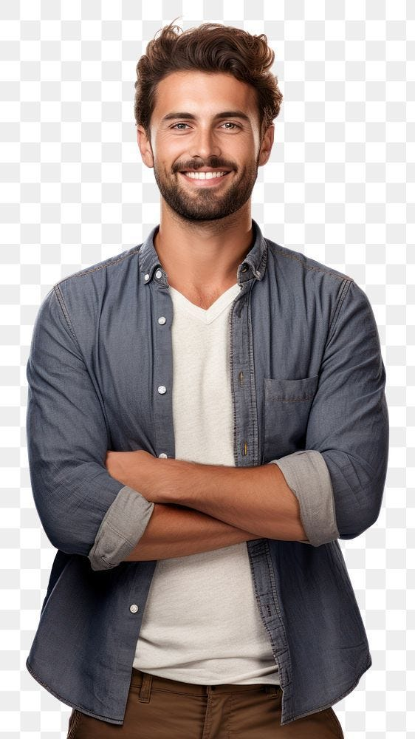

Ausgangsbild, nachfolgend einige Prompts dazu:

CEO

|  |
| --- |
| Transform the casual photo into a Fortune 500 CEO portrait with impeccable business attire, confident posture, and a modern office environment backdrop. Include subtle power accessories like a luxury watch, leather portfolio, and city skyline view through floor-to-ceiling windows. Lighting should convey authority and success. |

Fashion Magazin

|  |
| --- |
| Convert the image into a high-fashion magazine cover shot with professional styling, dramatic makeup, and avant-garde fashion elements. Add magazine masthead, cover lines, and barcode details. Include studio lighting effects with rim lighting and fashion-forward color grading. |

Kunstwerk

|  |
| --- |
| Recreate the photo in the style of a Renaissance master painting with oil paint textures, classical lighting techniques, and period-appropriate clothing. Add subtle cracking effects, golden frame edges, and museum-quality presentation with informational placard. |

Poster

|  |
| --- |
| Transform into a Hollywood blockbuster movie poster with dramatic lighting, action-oriented pose, and professional typography treatment. Include billing block text, movie ratings, and studio logos. Add atmospheric effects like smoke, sparks, or magical elements depending on genre. |

Fashion Runway Model

|  |
| --- |
| Convert the subject into a high-fashion runway model with editorial styling, avant-garde clothing, and professional catwalk lighting. Include audience silhouettes, camera flashes, and fashion week atmosphere with dramatic shadows and highlights. |

Hollywood 50-60s Star

|  |
| --- |
| Recreate as a 1940s Hollywood glamour portrait with classic hairstyling, elegant evening wear, and studio lighting reminiscent of golden age photography. Add subtle film grain, sepia toning, and ornate art deco design elements. |

Wissenschaftler National Geographics

|  |
| --- |
| Transform into an adventurous National Geographic explorer portrait with authentic outdoor gear, weathered appearance, and exotic location backdrop. Include environmental storytelling elements like maps, camping equipment, and natural lighting that suggests epic journeys. |

Sports Illustrated Magazin

|  |
| --- |
| Convert into a professional sports portrait with dynamic action pose, athletic wear, and stadium or training facility background. Add motion blur effects, sweat details, and dramatic sports lighting that captures peak athletic performance. |

Time Magazin

|  |
| --- |
| Create a Time Magazine cover-worthy portrait with authoritative pose, professional attire, and sophisticated background setting. Include the iconic red border frame, Time logo, and ‘Person of the Year’ typography with appropriate year designation. |

Dokumentationen – Portrait

|  |
| --- |
| Transform into a powerful documentary-style portrait with authentic emotions, environmental context, and photojournalistic composition. Include natural lighting, genuine expressions, and storytelling elements that convey deeper human experience and social awareness. |